Solution

Step 1: Open the Hex Workshop.

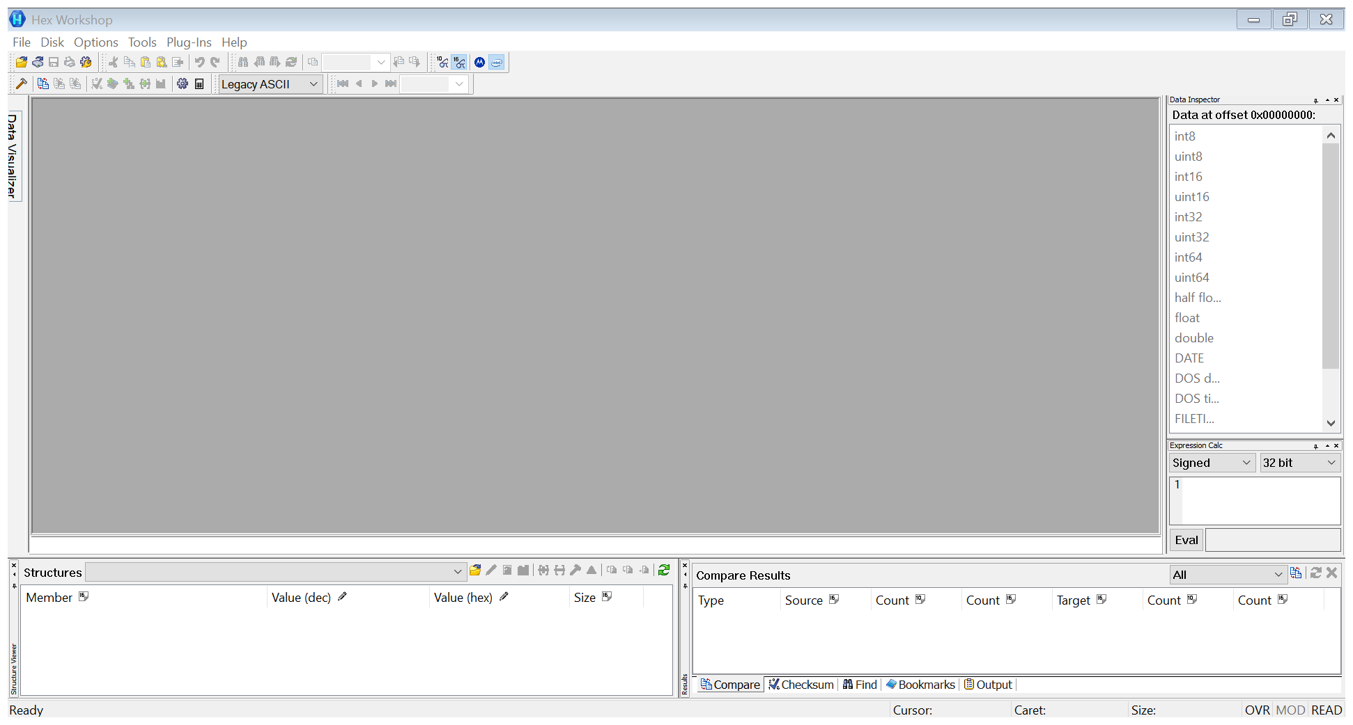

Step 2: Open the Project4.txt file. Go to **File> Open…**

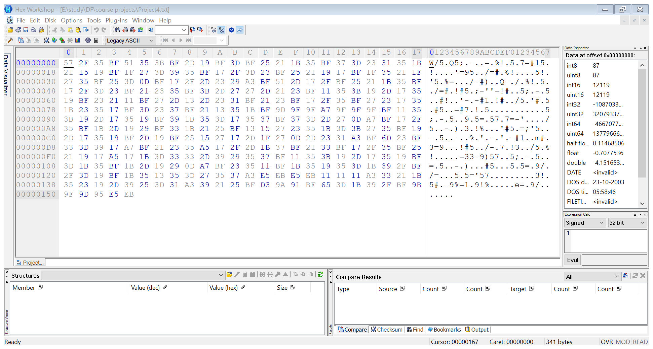

Use various Data Operations to restore the scrambled bits to their original order.

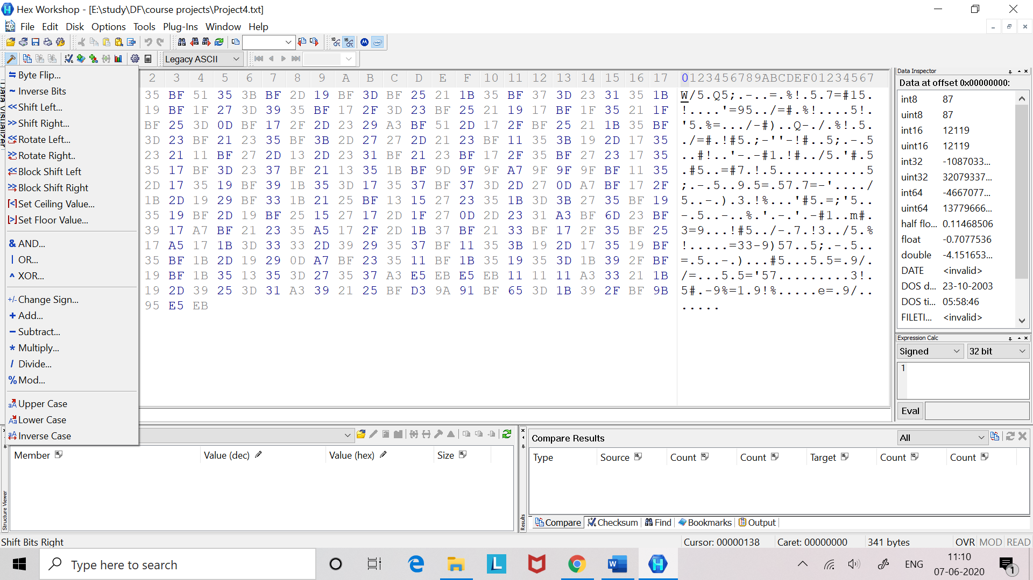

Step 3: Inverse the Bits.

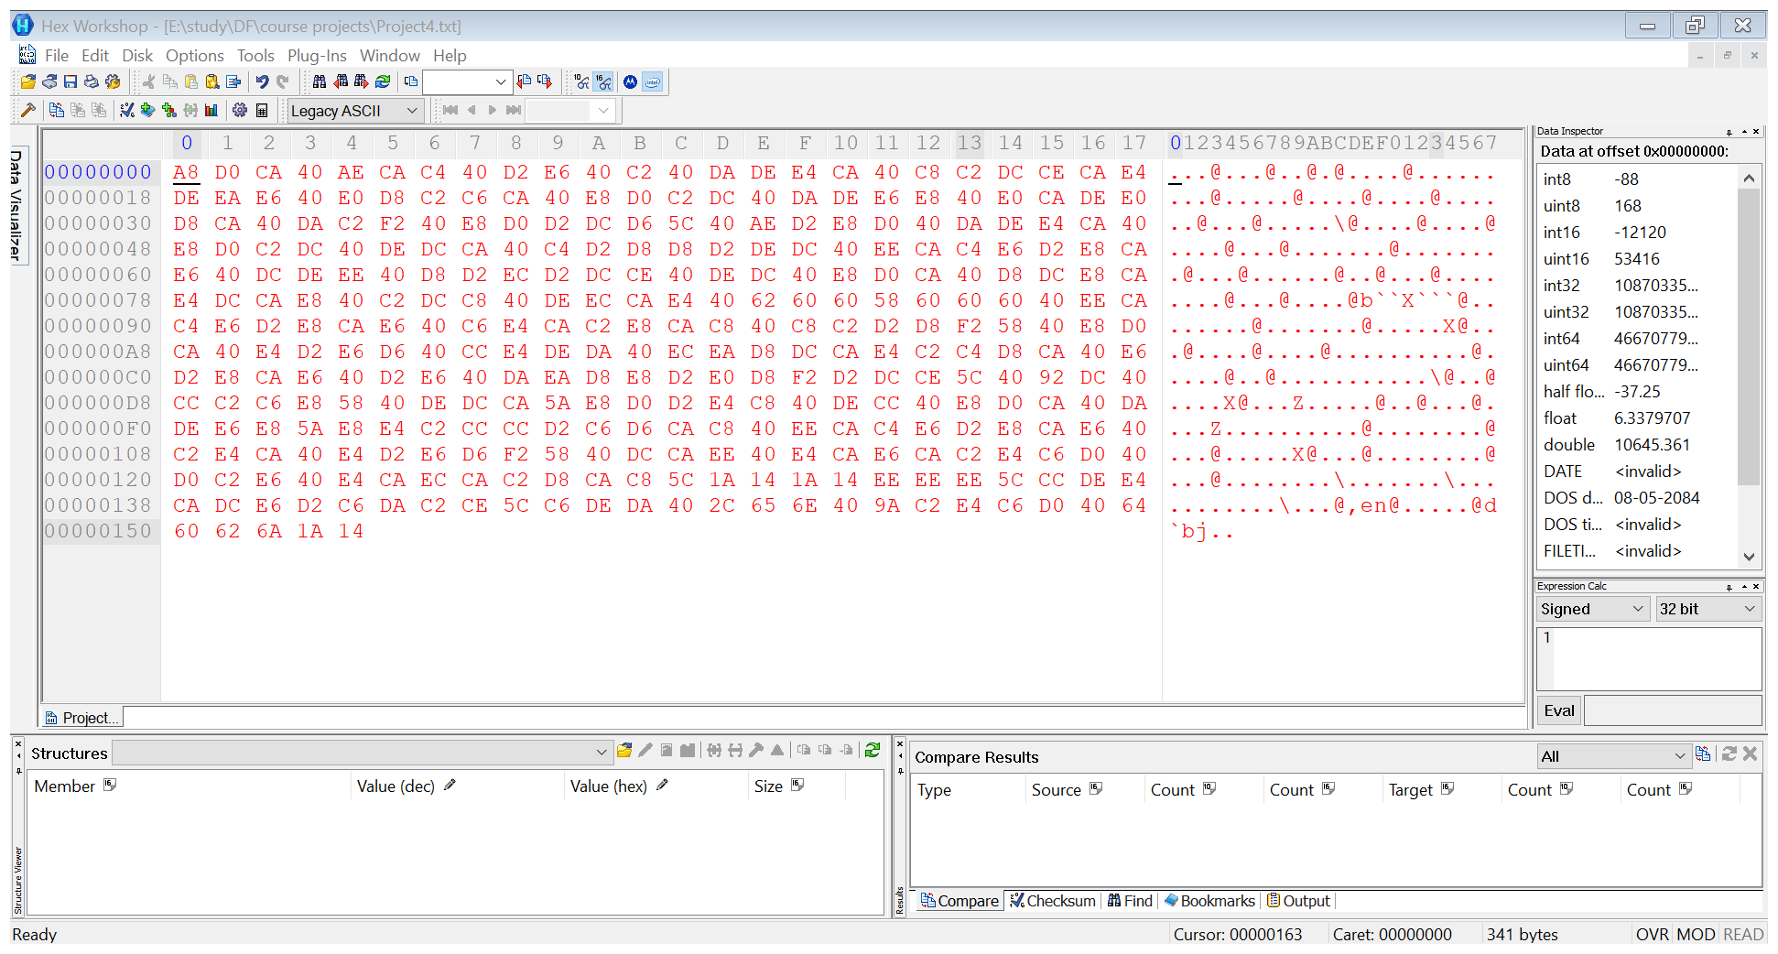

Step 4: Shift Right.

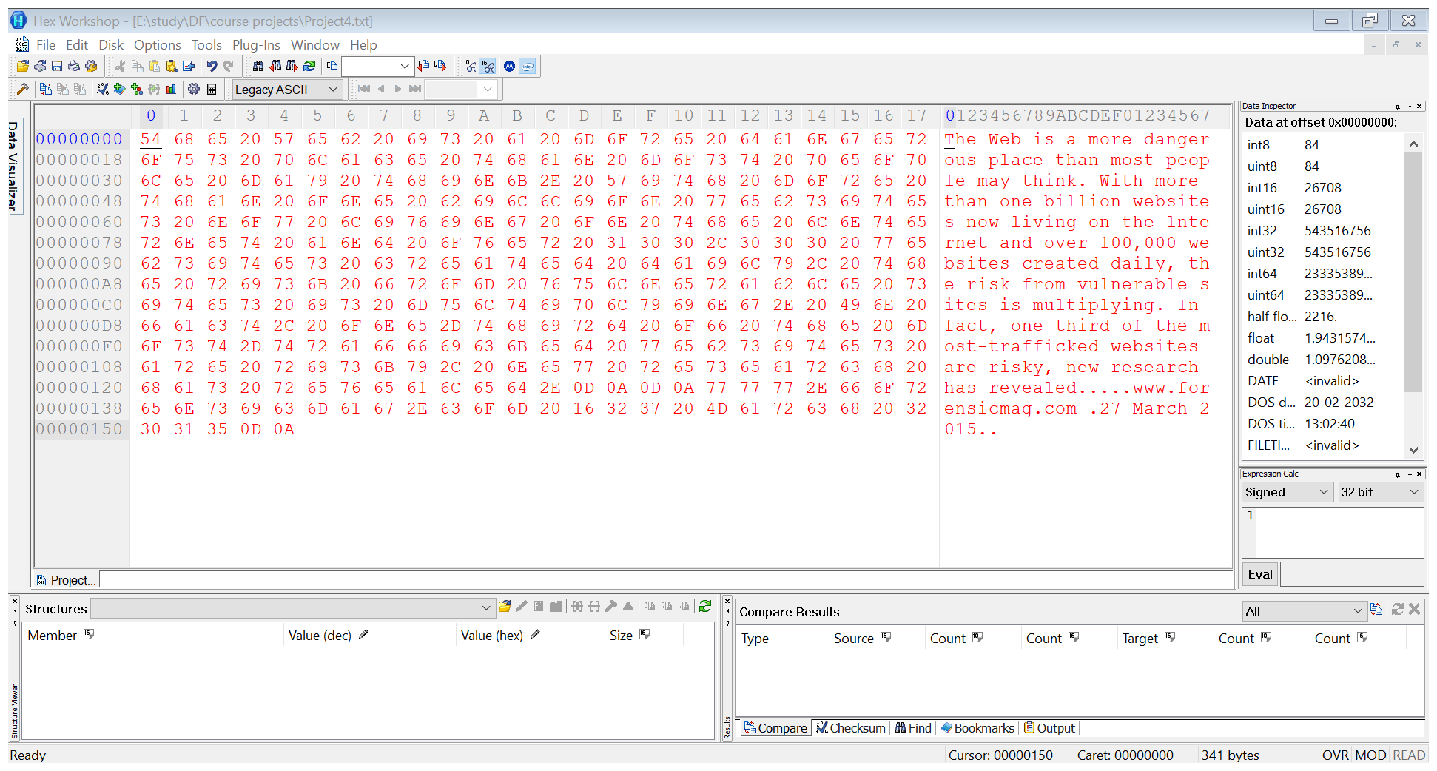

**Here, we got the original data:-**

The Web is a more dangerous place than most people may think. With more than one billion websites now living on the lnternet and over 100,000 websites created daily, the risk from vulnerable sites is multiplying. In fact, one-third of the most-trafficked websites are risky, new research has revealed.....www.forensicmag.com .27 March 2015..